1. In the previous version, we showed the Model Number / Part Number as the first row in the specs table. I realise that Lenovo are no longer showing it in the table, but could you please add the “Model Number” back as the first row? The model number can be sourced either from the input config.json file, or from above the new Lenovo specs table.

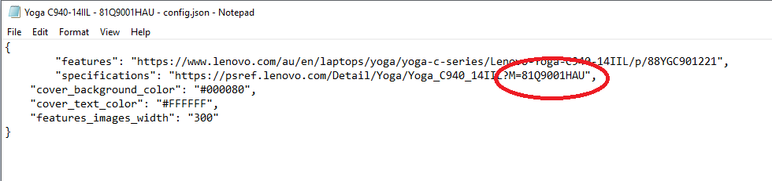

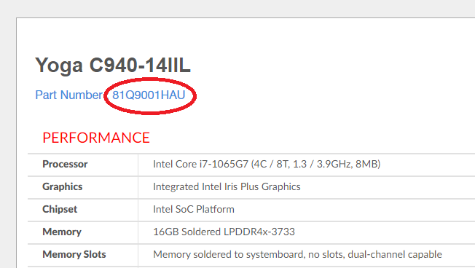

1. Some of the spec items have multiple rows of info, and are shown as dot points by Lenovo. For example, ‘Standard Ports’ and ‘Green Certifications’. The output is merging these multiple rows into a single text string, which makes it difficult to read. Could you please use dot points, or new lines or similar?

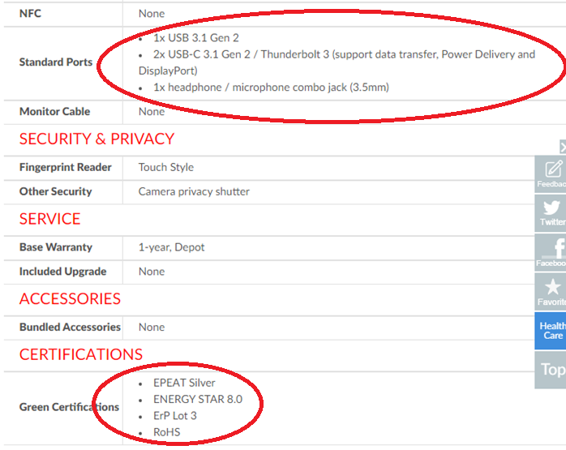

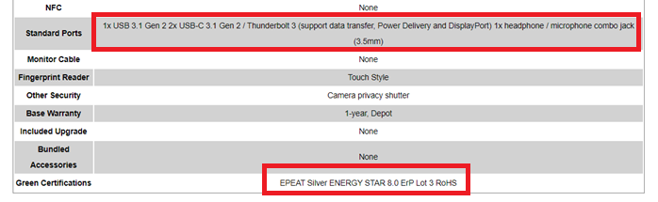

1. There are 3 further details that were previously in the specs table, but Lenovo has moved them (shown in image below). Could you please add these to the bottom of the output specs table?

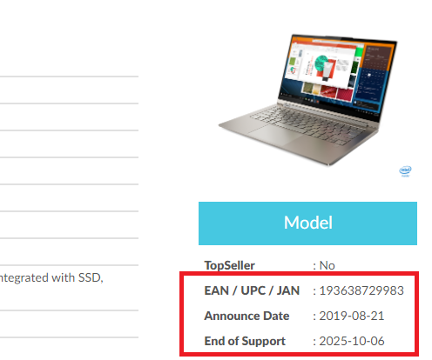

1. There are some graphics in the new output, which I can’t see in the Lenovo pages. Can you please remove these?

